UCS310: Database Management System Project



Pharmacy Management System

EVENSEM 2018-19

SUBMITTED BY SUBMITTED TO

Abhishek Bansal: 101703022(COE1) Ms. Harkiran Kaur

Abhishek Maira: 101703026(COE2)

Akshita Goyal:101703052(COE1) SUBMITTED ON

07 May 2019

DEVELOPED IN

Oracle Sql Plus for SQL and PL/SQL

INDEX

1. Introduction 3
2. ER diagram of the database 4
3. Conversion of ER diagram to tables 5
4. Normalized 6
5. PL/SQL queries and snap shots 8
6. Snap Shots of the tables 12
7. References 23

INTRODUCTION

REQUIREMENT ANALYSIS

**Problem Statement: Develop a general purpose Pharmacy Management System to be used by a parent pharmacy.**

**Objective**

It is a user friendly application for pharmacists which reduces the burden of their work and helps them to manage pharmacy sections like medicine management, billing etc. which improves processing efficiency. It deals with the automating task of maintaining bills. In pharmacy, billing management is the key process.

**Need**

The process of designing and implementing record keeping systems has significant accountability and resource implications for an organization. Feasibility analysis will help you make informed and transparent decisions at crucial points during the developmental process to determine whether it is operationally, economically and technically realistic to proceed with a particular course of action.

**Functional requirement**

1. The admin’s privileges are role based, thereby allowing role based access control of security.

2. Each user’s IP address is stored in the database for security.

3. Any user of the system is banned after 4 failed authentication processes.

4. Users can view products out of stock but cannot card them to cart.

5. Each user has a unique identifier.

**Brief introduction about technique used:**

With the processing as described above, it was possible to start coding for the project. This tool uses PLSQL procedures to insert values into some tables, the ones with auto incrementing primary keys. This is so that the programmer doesn’t need to insert the values of those fields explicitly. These values are inbuilt in the code of the procedures. Another quite possible challenge is iterative searches in the densely populated tables. To solve these issues, the tool is equipped with PL/SQL functions that search as per the need and return a VARCHAR2 literal with the result. This result can then be displayed on the screen, or used for further processing at the backend, as per the requirement. On successful insertions of records in any table, Triggers are called which inform the insertion status to the user on the DBMS console. This output can certainly be used to process and check status according to requirement of future scaling of the project. All the fields capable of Auto incrementing values are supported by sequences which can be used to auto-generate the next value of the tuple.

ER DIAGRAM OF THE DATABASE

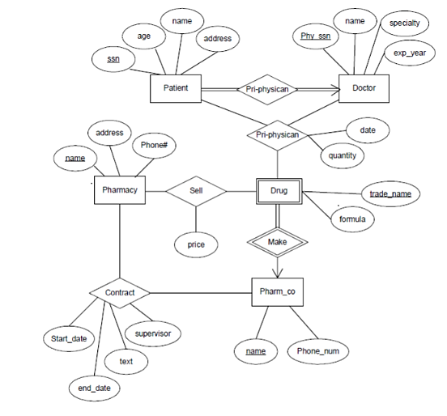

CONVERSION OF ER DIAGRAM TO TABLES

Patient

ssn age name address

Doctor

phy_ssn name speciality exp_years

Drug

trade_name Pharm_co.name formula

Pharm_co

name phone_num

Pharmacy

name address phone#

Pri_physician

ssn phy_ssn

Prescription

ssn phy_ssn Pharm_co.name trade_name date quantity

Make

Pharm_co.name trade_name

Sell

Pharmacy.name Pharm_co.name trade_name

Contract

Pharmacy.name Pharm_co.name start_date end_date text supervisor

**NORMALIZED TABLES**

**patient**

|  |  |  |  |
| --- | --- | --- | --- |
| **ssn** | **age** | **name** | **address** |

**doctor**

|  |  |  |  |
| --- | --- | --- | --- |
| **Phy_ssn** | **name** | **speciality** | **Exp_years** |

**drug**

|  |  |
| --- | --- |
| **Trade.name** | **formula** |

**Pharm_co**

|  |  |
| --- | --- |
| **name** | **Phone_num** |

**Pri_physician**

|  |  |
| --- | --- |
| **ssn** | **Phy_ssn** |

**prescription**

|  |  |  |  |  |
| --- | --- | --- | --- | --- |
| **ssn** | **Phy_ssn** | **Pharmco_name** | **Trade_name** | **quantity** |

**Make**

|  |  |
| --- | --- |
| **Pharm co.name** | **Trade_name** |

**Sell**

|  |  |  |
| --- | --- | --- |
| **Pharmacy.name** | **Pharmco.name** | **Trade_name** |

**Contract**

|  |  |  |  |  |
| --- | --- | --- | --- | --- |
| **Pharmacy.name** | **Pharmco.name** | **Start_date** | **End_date** | **text** |

|  |  |  |
| --- | --- | --- |
| **Pharmacy.name** | **Pharmco.name** | **superviser** |

PL/SQL QUERIES

Following are the PL/Sql queries used along with comments about their usage.

**Procedure-1**

**//displaying medicines with largest quantites**

SET SERVEROUTPUT ON;

create or replace procedure printquantity_largest is

MEDNAME prescription.trade_name%TYPE;

prescriptionquantity prescription.quantity%TYPE;

CURSOR TEMP1 IS SELECT trade_name,quantity FROM prescription

ORDER BY quantity DESC;

BEGIN

OPEN TEMP1;

LOOP

FETCH TEMP1 INTO MEDNAME,prescriptionquantity;

EXIT WHEN TEMP1%ROWCOUNT>5 OR TEMP1%NOTFOUND;

DBMS_OUTPUT.PUT_LINE(MEDNAME||prescriptionquantity);

END LOOP;

CLOSE TEMP1;

END;

/

**Procedure-2**

**//displaying medicines with smallest quantites**

Create or replace procedure printquantity_smallest is

MEDNAME prescription.trade_name%TYPE;

prescriptionquantity prescription.quantity%TYPE;

CURSOR TEMP1 IS SELECT trade_name,quantity FROM prescription

ORDER BY quantity;

BEGIN

OPEN TEMP1;

LOOP

FETCH TEMP1 INTO MEDNAME,prescriptionquantity;

EXIT WHEN TEMP1%ROWCOUNT>5 OR TEMP1%NOTFOUND;

DBMS_OUTPUT.PUT_LINE(MEDNAME||prescriptionquantity);

END LOOP;

CLOSE TEMP1;

END;

/

**Procedure-3**

**//displaying patient details**

create or replace procedure patient_details(patient_name varchar) is

v_age number(10);

v_name varchar(20);

v_address varchar(100);

BEGIN

select age,name,address into v_age,v_name,v_address from Patient where name=patient_name;

DBMS_OUTPUT.PUT_LINE('NAME: ' || v_name);

DBMS_OUTPUT.PUT_LINE('ADDRESS: ' || v_address);

DBMS_OUTPUT.PUT_LINE('AGE: ' || v_age);

END;

/

**Procedure-4**

**//displaying doctor details**

create or replace procedure doctor_details(doctor_name varchar) is

v_expyears number(10);

v_name varchar(20);

v_speciality varchar(20);

BEGIN

select name,speciality,exp_years into v_name,v_speciality,v_expyears from Doctor where name=doctor_name;

DBMS_OUTPUT.PUT_LINE('NAME: ' || v_name);

DBMS_OUTPUT.PUT_LINE('SPECIALITY: ' || v_speciality);

DBMS_OUTPUT.PUT_LINE('EXP_YEARS: ' || v_expyears);

END;

/

**Procedure-5**

**//** **pharmacy company that makes a particular drug**

create or replace procedure get_pharmco(tradename varchar) is

v_name varchar(20);

BEGIN

select pharmco_name into v_name from Drug where trade_name=tradename;

DBMS_OUTPUT.PUT_LINE('PHARMCO_NAME: ' || v_name);

END;

/

**Procedure-6**

**// insert/delete/update combined procedure**

create or replace procedure MasterInsertUpdateDelete

(id INTEGER, v_name VARCHAR,v_age NUMBER,v_address VARCHAR,StatementType nvarchar:= '' )

AS

BEGIN

IF StatementType='Insert' THEN

insert into Patient (ssn,name,age,address) values( id,v_name,v_age,v_address);

END IF;

IF StatementType='Select' THEN

select * from Patient;

END IF;

IF StatementType='Update' THEN

UPDATE Patient SET

name:=v_name,age:=v_age,

address:=v_address

WHERE ssn:= id;

END IF;

ELSIF StatementType='Delete' THEN

DELETE FROM Paient WHERE ssn:=id;

END IF;

end;

/

**Procedure-7**

**//trigger check before updating number of medicines to be prescribed**

CREATE OR REPLACE TRIGGER UPDATE_CHECK

BEFORE UPDATE ON prescription

FOR EACH ROW

BEGIN

IF :NEW.quantity<:OLD.quantity THEN

RAISE_APPLICATION_ERROR(-20000,'NEW quantity CANNOT

BE LESS THAN OLD quantity');

END IF;

END;

/

SNAP SHOTS OF THE PL/SQL QUERIES

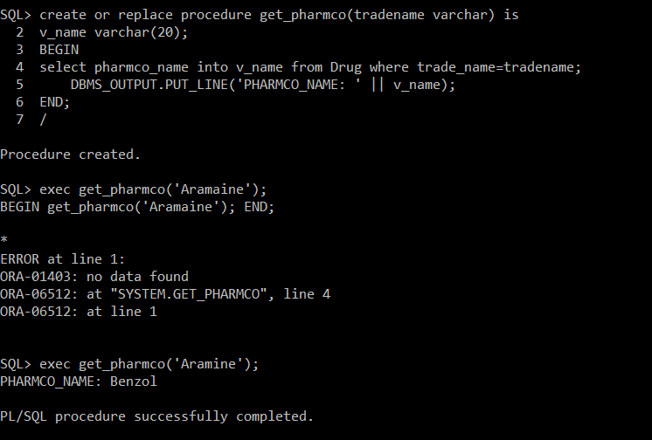



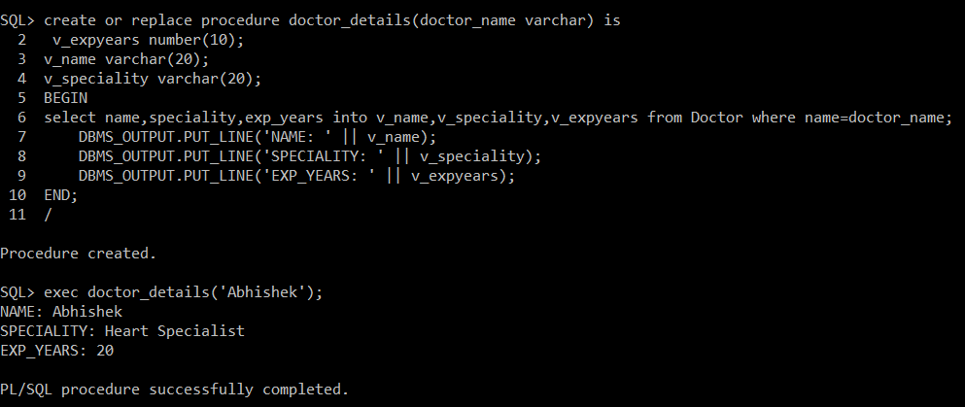

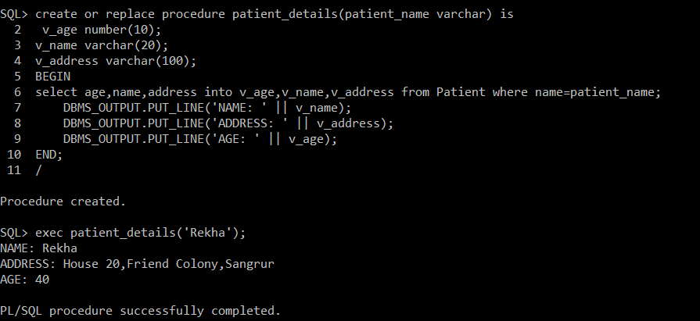

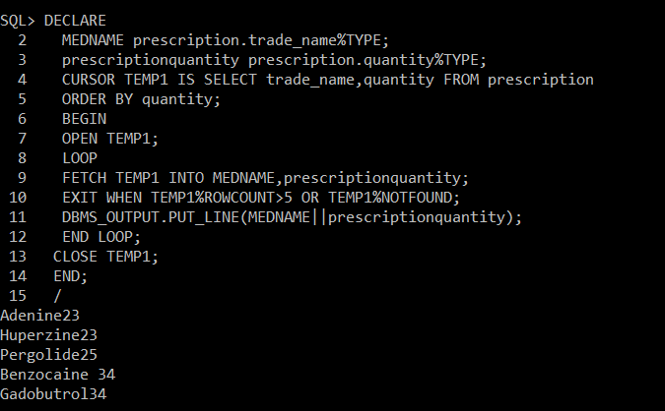

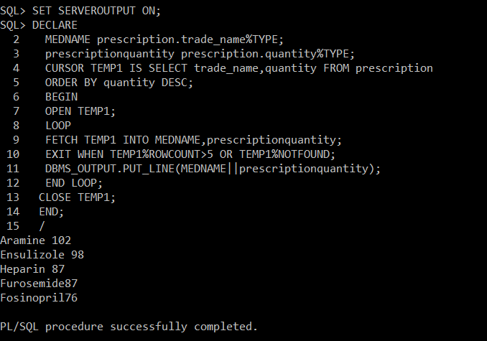

SNAP SHOTS OF SOME OF THE TABLES CREATED

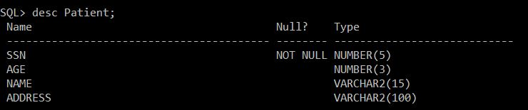

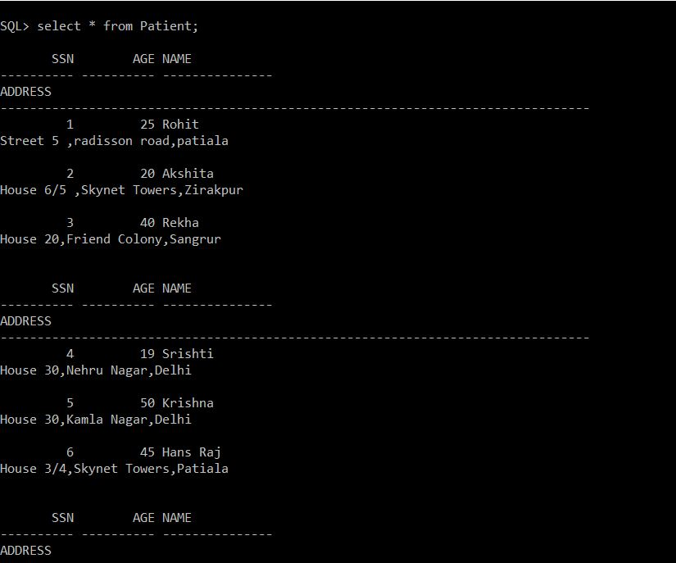

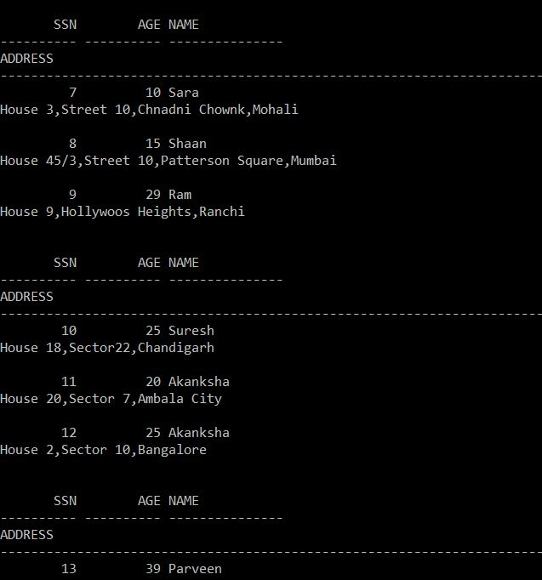

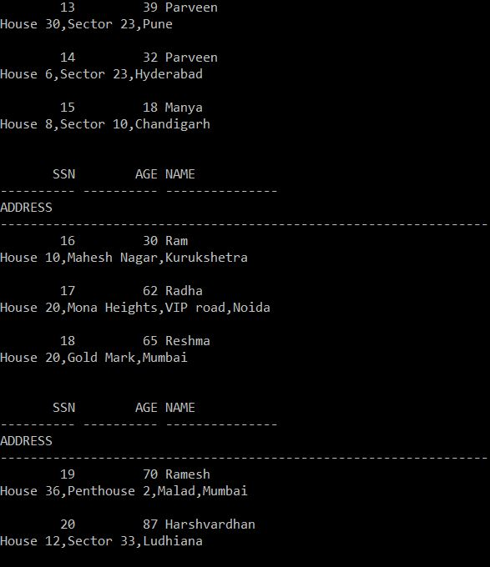

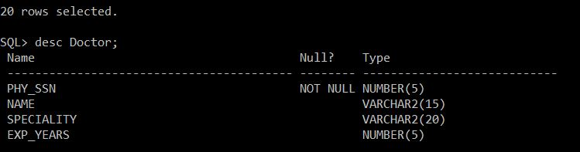

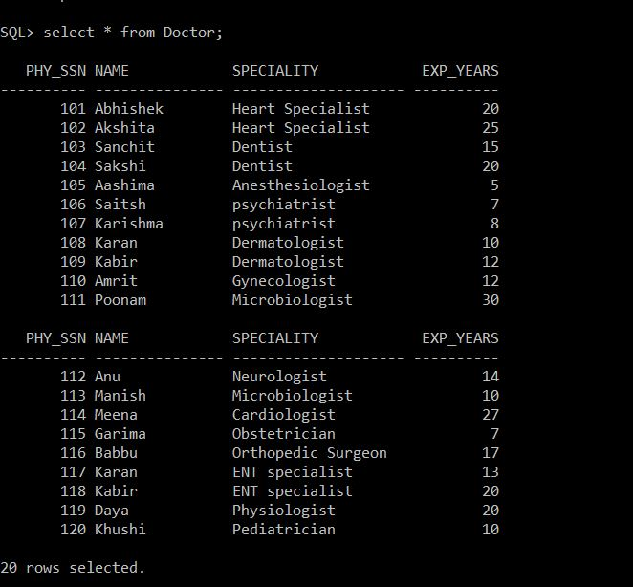

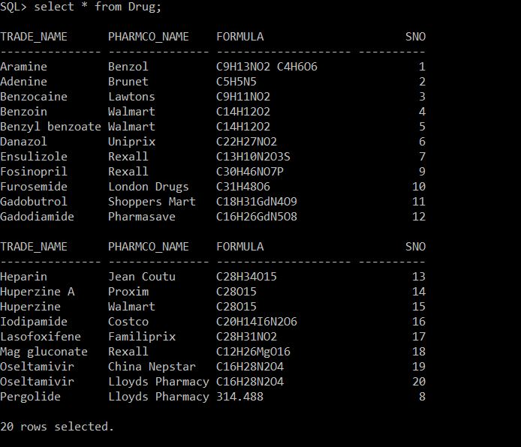

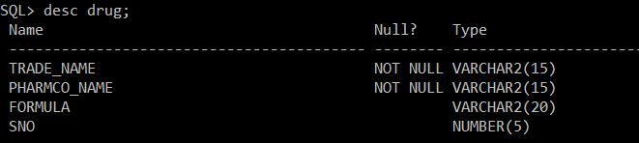

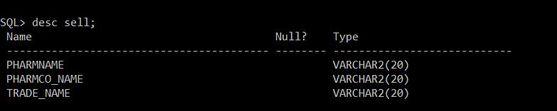

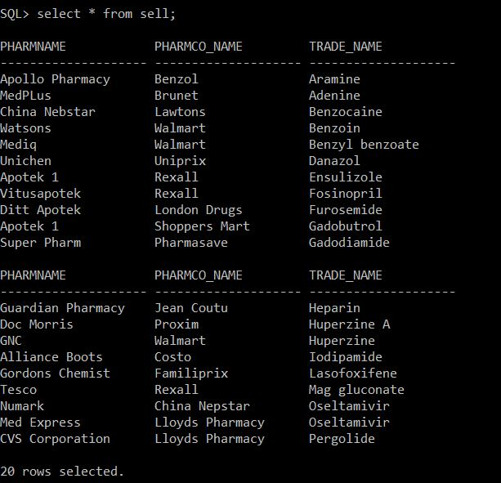

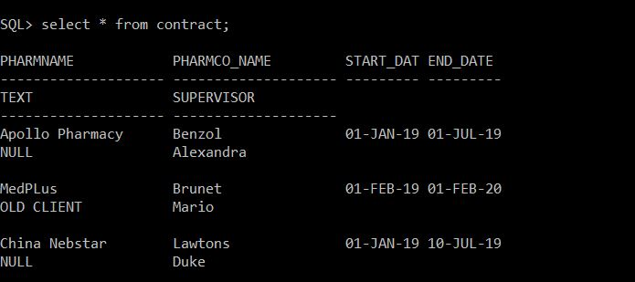

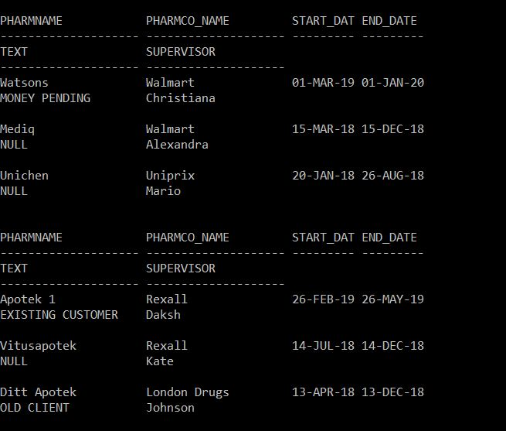

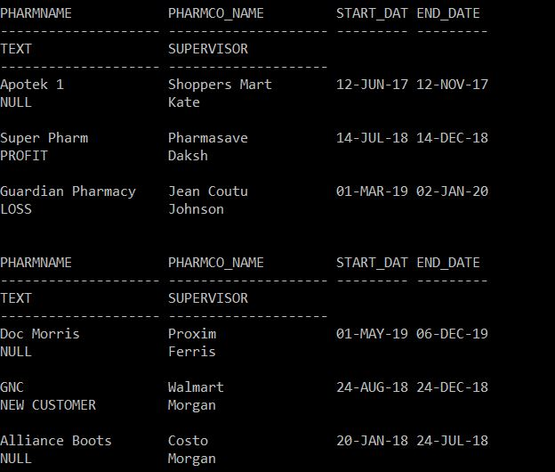

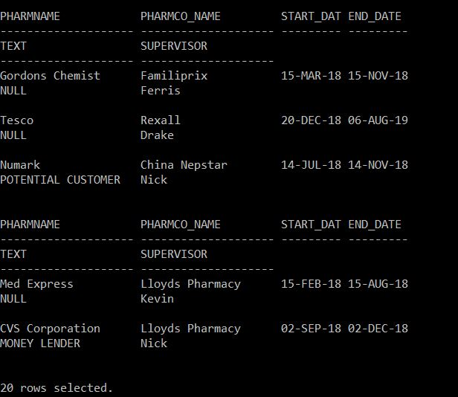

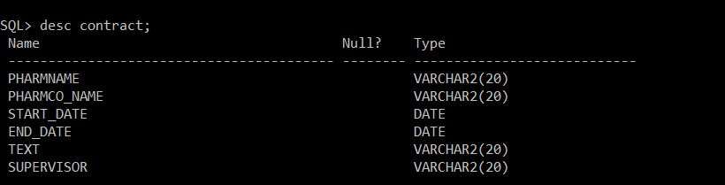

REFERENCES

<https://en.wikipedia.org/wiki/PL/SQL>

<https://github.com/sanchit-nayyar/SQL_Project>

<https://www.youtube.com/watch?v=-OR7zLzCh_I&list=PLL_LQvNX4xKyiExzq9GKwORoH6nvaRnOQ&index=15>

<https://sites.google.com/site/dbms310cse/lecture-notes>